**~~~~~~ Prototype ~~~~~~**

**Smart Stock Stealing Prevention POS for Restaurant**

**Functional Requirements of Prototype:**

1. Admin / Waiter / Manager / Accountant should be able to login into system using password and PIN code via both options.

**Login using Email address and Password  
  
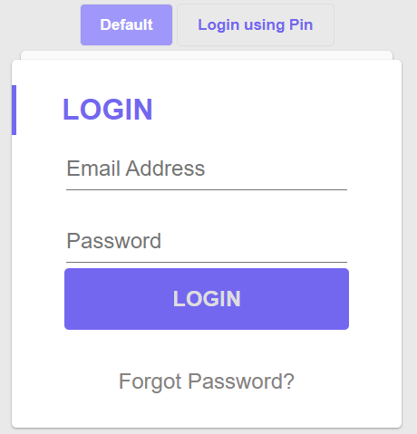**

**Login using Pin**

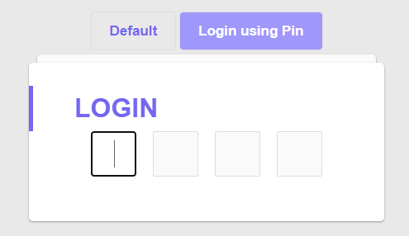

1. Admin should manage all users / user roles and activate or de-activate any user at any time. Implement all these features given below in the figure.

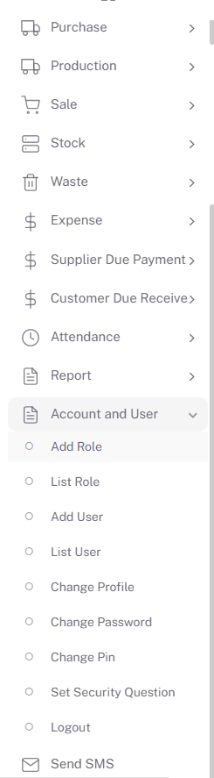

1. Admin Should be able to do the following tasks:

**Food Item Module Management**

1. [Add Ingredient Unit](http://pos.alphatech.pk/Unit/addEditUnit)
2. [List Ingredient Unit](http://pos.alphatech.pk/Unit/Units)
3. [Add Ingredient Category](http://pos.alphatech.pk/ingredientCategory/addEditIngredientCategory)
4. [List Ingredient Category](http://pos.alphatech.pk/ingredientCategory/ingredientCategories)
5. [Add Ingredient](http://pos.alphatech.pk/ingredient/addEditIngredient)
6. [List Ingredient](http://pos.alphatech.pk/ingredient/ingredients)
7. [Add Modifier](http://pos.alphatech.pk/modifier/addEditModifier)
8. [List Modifier](http://pos.alphatech.pk/modifier/modifiers)
9. [Add Food Menu Category](http://pos.alphatech.pk/foodMenuCategory/addEditFoodMenuCategory)
10. [List Food Menu Category](http://pos.alphatech.pk/foodMenuCategory/foodMenuCategories)
11. [Add Food Menu](http://pos.alphatech.pk/foodMenu/addEditFoodMenu)
12. [List Food Menu](http://pos.alphatech.pk/foodMenu/foodMenus)
13. [Add Pre-Made Food](http://pos.alphatech.pk/PreMadeFood/addEditPreMadeFood)
14. [List Pre-Made Food](http://pos.alphatech.pk/PreMadeFood/preMadeFoods)
15. Admin should maintain stock entry received from supplier using the stock entry form for the food items to be used as ingredients in the recipe of Food menu items.
    * + 1. [**Add Supplier**](http://pos.alphatech.pk/supplier/addEditSupplier)
        2. [**List Supplier**](http://pos.alphatech.pk/supplier/suppliers)
        3. [**Add Purchase**](http://pos.alphatech.pk/Purchase/addEditPurchase)
        4. [**List Purchase**](http://pos.alphatech.pk/Purchase/purchases)

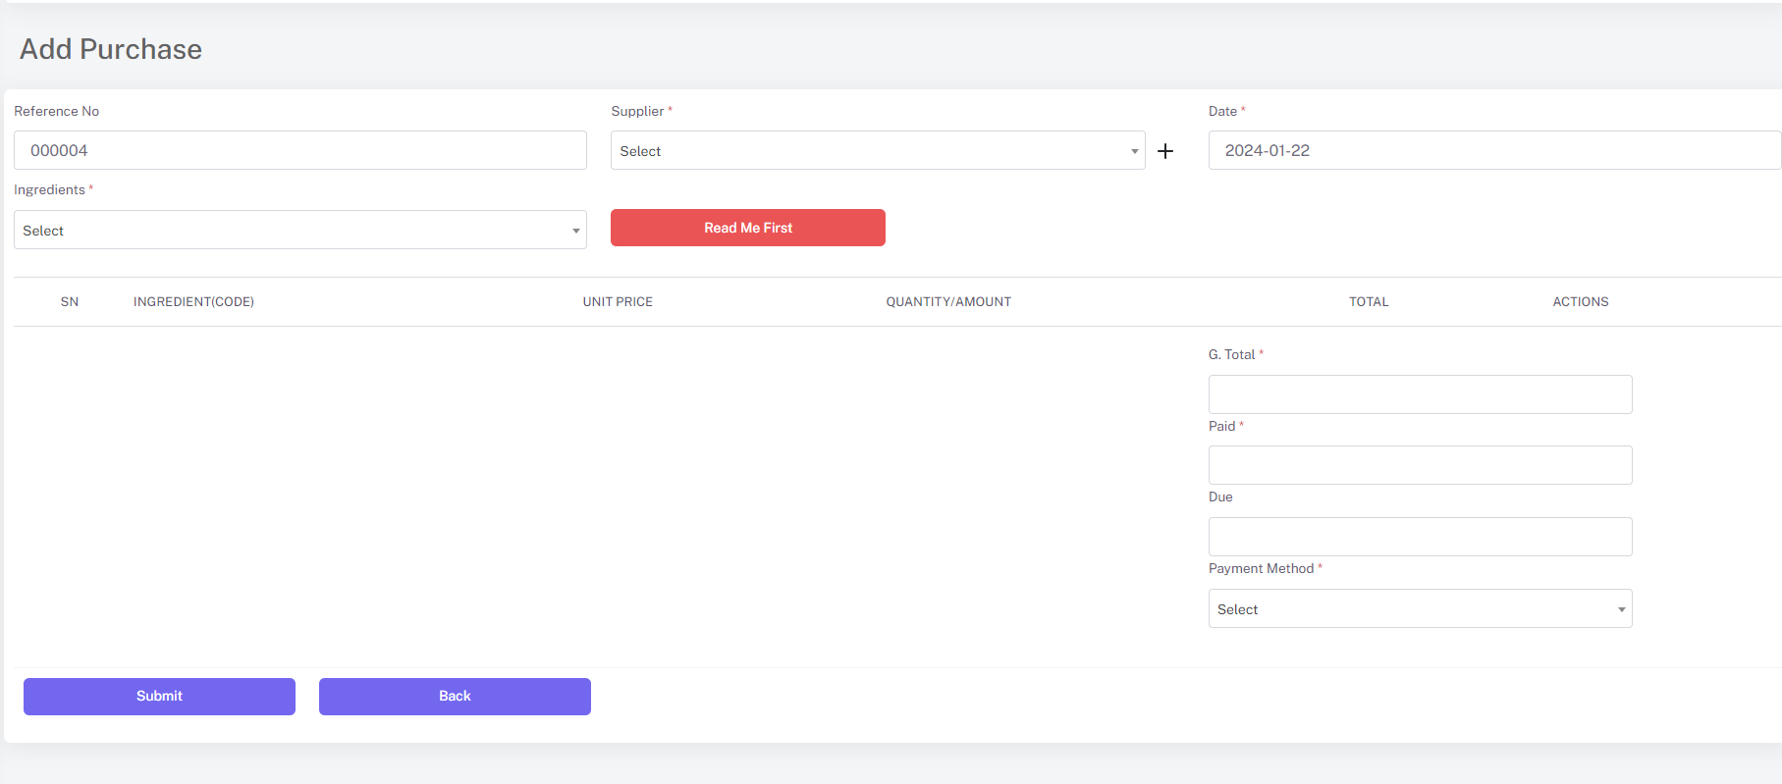

1. User should Make Recipe for Food, and when make a Sale, Stock should be Auto Deducted.

**Add Food Menu ( for Tracking Stock Consumption):**

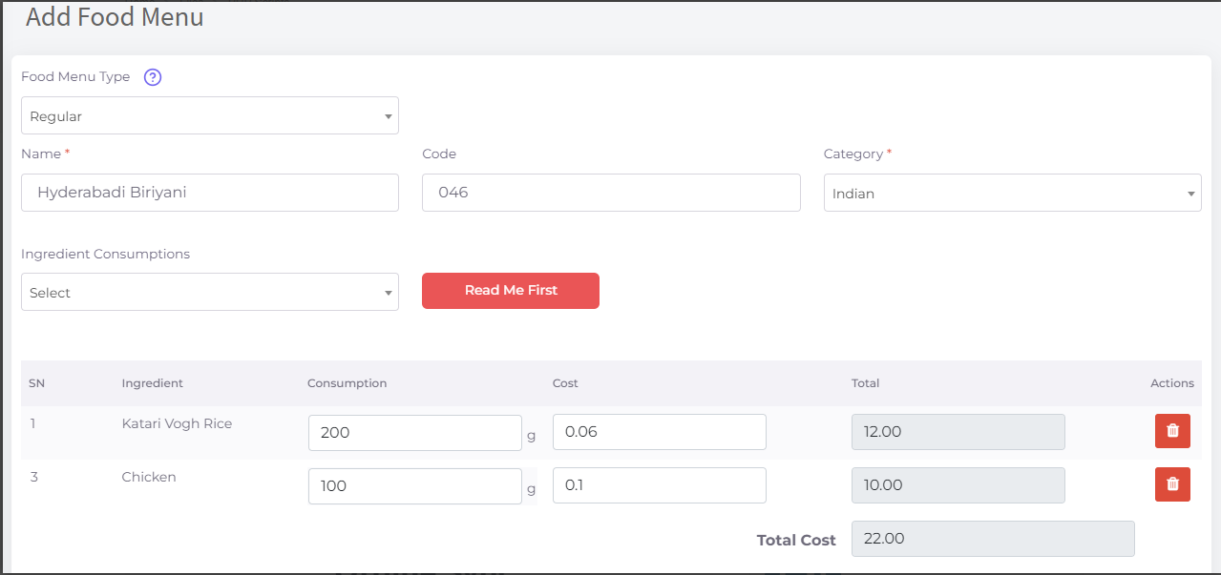

**Tools:**

Use Any Web Development Technology like PHP, Java, ASP.NET, PWA etc.

**Supervisor:**Name: Shakeel Saeed

Email ID: [shakeel@vu.edu.pk](mailto:shakeel@vu.edu.pk)

Skype ID: shakeelsaeedvurnd

Skype Profile Link: <https://join.skype.com/invite/yIuFlFa5L1Pc>